**GUIDELINES FOR PROCESS FOR PULVERIZED COAL INJECTION TO FURNACE**

1. **PURPOSE:** To have a normal pulverized coal injection process & avoid abnormality.
2. **SCOPE:** Un-interrupted PCI

1. **RESPONSIBILITY:** **EMPLOYEES WORKING IN THE PCI OPERATION**
2. Always ensure that the Fine Coal Bin is maintained minimum of 20 ton (which is a backup for 8 hrs. for both furnaces).
3. Ensure the manual gate valve for all four conveying hoppers (injection tank) below fine coal silo is open 100%.
4. Then ensure that valves V117 for BF#1 and V317 for BF#2 (before distributor) is open and pressure is maintained above 100 kPa than the hot blast pressure. Also ensure both the PT-218(BF1) and PT-219(BF2) are flushed by instrumentation at regular intervals as malfunctioning/slow measuring by the same will give wrong feedback to both V117 and V317 and the same might not close in the event of coal line getting depressurized below the safe differential limit.
5. Ensure that the empty hoppers (1,2,3,4) pressure should be zero or less than 1 kPa, if not then open valve (104,204,304,404)

* Hopper 1&2 for BF#1.
* Hopper 3&4 for BF#2.

For filling of Hopper-1:

1. Open valve -102 then valve-101 and close valve-103 of hopper 1.
2. When coal quantity reaches 4500kg then close the valve 101 then after 30 sec, close valve 102 and open valve 103.
3. Ensure that the nitrogen pressure should be 600kpa and above and compressed air should be 600kpa and above in the storage tanks/ receivers.
4. Then start pressurizing hopper-1 with nitrogen by opening valves 105 & 107 as well as ensure regulating valves 106 & 108 are open 100%. When the pressure reaches minimum 350kpa then close both valves 105 & 107. Now the coal is ready to inject in furnace from hopper 1.
5. Before start of injection ensure that all the lances are sufficiently centered with respect to tuyere monkey so as to avoid coal hitting the same while being injected and for the lance whose line has gotten punctured needs to be kept in nitrogen mode. And coal line pressure should be maintained greater than 100kpa from hot blast pressure by regulating the conveying line valve (112, 113).
6. Then open feeder flushing valve and feeder outlet valve simultaneously start feeder and set the injection rate as per requirement of furnace. Feeder has two modes- manual and auto: first use manual mode then after normalizing the injection use auto mode to transport the coal.
7. After injection starts observing whether coal injection rate in positive or negative, set feeder frequency as per requirement of current deviation. And also valve no 113 should be regulated by observing the HB pressure.
8. Once the injection rate is normalized, ask operator to check whether the coal injection to furnace is proper or not at tuyere platform. If yes then put the injection system in auto mode, if not then adjust the feeding frequency higher or lower. After clearance given by operator put in auto mode.
9. Then on the HBS interlock block, ensure that it is in ON (active) mode always to prevent accident of lance or hose burning.
10. At the same time set lower coal quantity to 500 kg and upper coal quantity at 4500 kg so as to ensure uninterrupted PCI during change over to other filled hopper.
11. The same process follows for the hopper 3&4 for bf#2 injection.

**NOTE:**

All the above should be always operate in auto mode, if in case coal is not injecting in auto mode, then use the manual mode to normalize the injection. After normalizing again put in auto mode.

Some important factors to be considered during coal injection & stoppage of injection.

During coal injection:

* Always monitor and supervise the coal injection system from control room.
* Ask to operator to check lance position (should be centered) and coal injection status hourly and maintain check list of injection status.
* The absence of oxygen and CO gas plays a great role in P.C.I, always ensure that oxygen should be less than 8% or CO should be less than 1 ppm. If gas increased beyond that level, then there is an accidental valve 601 which will open above 12% of oxygen and 500 ppm of CO gas.
* If even after opening of valve 601 the gas percentages are not reducing then open fluidizing valve 602 to dilute the gas.
* Always ensure to keep the PCI area clean and dry by regular housekeeping to avoid fire incident. Ensure fire extinguishers in healthy condition & in proper earmarked places as well as the firefighting line should be charged, and hose pipe and water spray nozzle should be in proper place.
* Use nitrogen purging or fluidizing regularly to avoid settlement of coal as well as to decrease the temperature if it increases more than 60ºC in fine coal silo.
* Flush the coal line by nitrogen at distributer by help of three-way valve in the case of high injection rate to avoid the coal line choke
* Maintain coal conveying line temperature 30ºC and above to avoid coal line jam.
* Maintain conveying line flow min 500 by observing FT402, if not, then regulate the regulating valve V113 for BF-1 and V313 for BF-2.
* Clean conveying line filter regularly to avoid coal injection disturbance in both the furnaces.

During stoppage of coal injection:

* Minor PCI leakages in particular lance / line can be attended by clamping if possible. Stop PCI in particular lance, flush lance with nitrogen and take out the lance for attending leakages.
* Always ensure that whenever furnace is cleared after shutdown, for startup, irrespective of whether the PCI will be started immediately or after certain duration, all lances should be inserted and compressed air or nitrogen to be supplied to avoid the lance port getting choked by slag or metal.
* In the case of long-term shutdown, the coal should be recirculate from fine coal silo hopper then from hopper fine coal silo by the help of recirculating line.
* If temperatures of fine coal silo drop below 40ºC then heater should open automatically and close when raises to 45ºC.

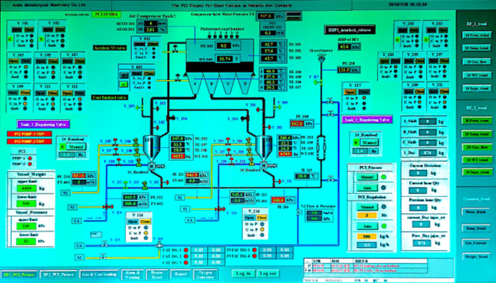

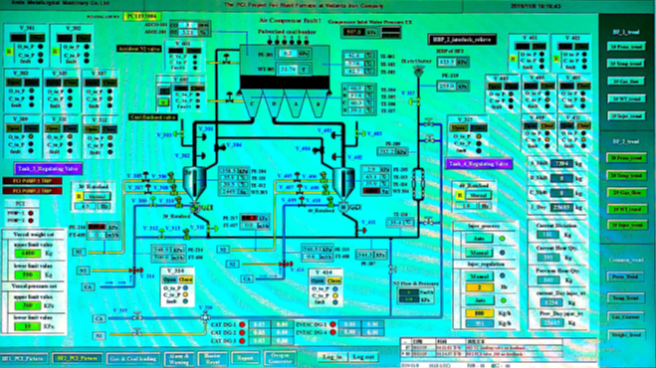



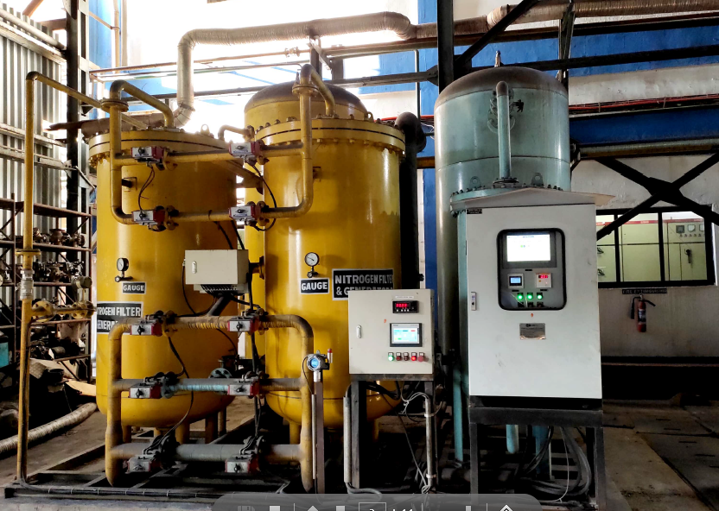

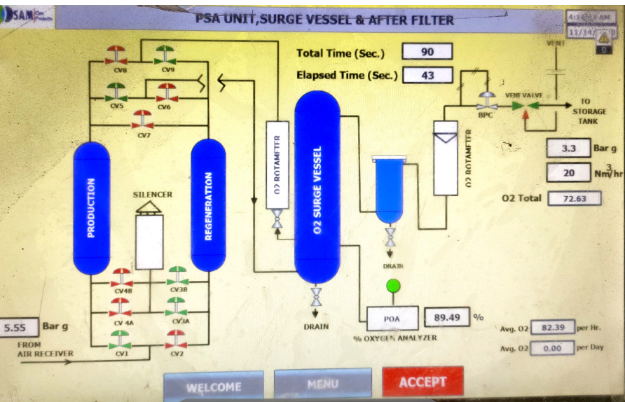

|  |  |  |
| --- | --- | --- |
| **Prepared By:**  Head – Process Control PID | **Reviewed & Issued By:**  Management Representative | **Approved By:**  Head – Head Pig Iron Division |
| **Signature:** | **Signature:** | **Signature:** |
| **Date: 15.07.2022** | **Date: 15.07.2022** | **Date: 15.07.2022** |